**Default parameter component value for ACT function**

ptanh_single_fault_all.csv

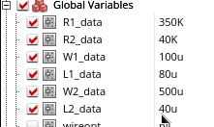

**Component values from Haibin**

ptanh_single_fault_haibin_13_short_open.csv

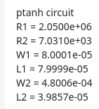

**R2_data_open stops simulation and doesnot converge after –0.01V, we can ignore this fault if you consider this component value**

**Default parameter for new_NEG function**

new_neg_wt_single_fault_all.csv

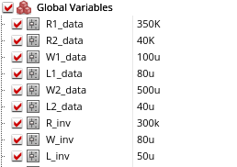

**R3_open stops simulation and doesnot converge, we ignore this fault if you consider this component value (and is not included in the .csv file)**

**Component value from Haibin for new_NEG function**

new_neg_wt_single_haibin_19_short_open.csv

